BUSINESS REQUIREMENTS DOCUMENT

Patient Appointment Booking System
Requirements specification for outpatient clinics (Digital Health)
By Angana Angel Nelson
13/10/2026

Contents
Project Overview
Use Case Diagrams
User Role
Business Objective and KPIs
Process Maps
As-Is
To-Be
Functional Requirements
Non-Functional Requirements
Business Rules
Appointment Status Cycle
User Stories and Acceptance Criteria
Exception Flows
Requirement Traceability Matrix.

Project overview
Clinics currently take bookings by phone and a paper register. Patients cannot book after hours, callers wait or redial when the receptionist is busy, and no reminders are sent, so missed appointments go unnoticed until the slot is wasted. The proposed system lets patients book, reschedule and cancel online at any time, sends automated reminders, offers freed slots to waiting patients, and gives reception, doctors and admin a single live schedule. This document specifies the business, functional and non-functional requirements for an online Patient Appointment Booking System for small and mid-sized outpatient clinics.
Use case diagram
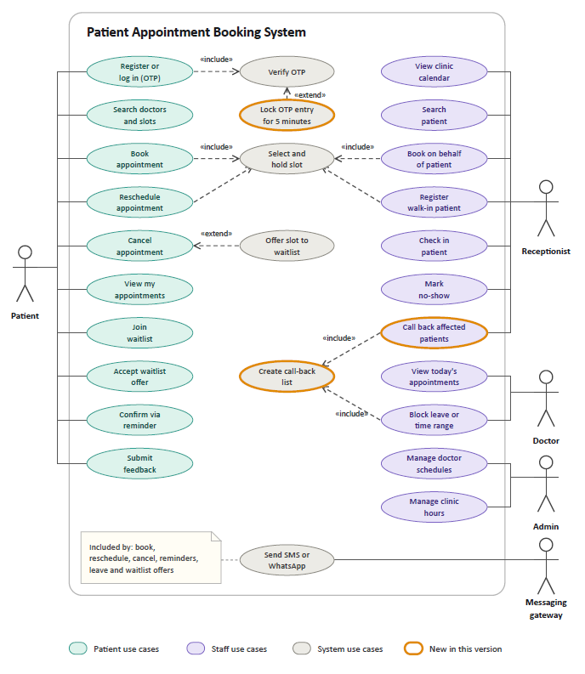
User roles
Role | Description
Patient | Registers, searches doctors, books, reschedules and cancels appointments, receives reminders and gives feedback. May be a guardian booking for a minor.
Doctor | Views the day's appointments and blocks leave or time ranges. Can define working hours together with the admin
Receptionist | Runs the reception console: books on behalf of callers, registers walk-ins, checks patients in and marks no-shows
Admin | Manages doctor schedules, clinic hours and users.

Business Objectives and KPIs
The system is justified by seven business objectives and each has a measurable KPI.
ID | Business Objective | KPIs | Measured from | Baseline | Target (proposed)
BO-1 | Reduce missed appointments | No-show rate | Appointment status records (No-show) | 20.2% (analysis of 110,527 appointments) | 15% or lower within 6 months of go-live
BO-2 | Shift booking to self-service | Share of bookings made online | Booking channel field (online, phone, walk-in) | 0% (since bookings are currently through phone and paper only) | 60% of bookings online within 6 months
BO-3 | Free up reception time | Booking-related phone calls per day | Clinic call log | To be measured: count calls in a 4-week pre-launch window | 40% reduction within 6 months.
BO-4 | Speed up booking | Average time to book | Booking timestamps (first search to confirmation) | To be measured | 3 minutes or less (consistent with NFR-16, 5 steps or fewer)
BO-5 | Recover idle doctor capacity | Share of cancelled slots refilled | Slot and waitlist records | 0% | 30% of cancelled slots refilled within 6 months
BO-6 | Improve patient experience | Average feedback rating (1 to 5) | Patient feedback ratings | None collected yet. | 4.2 or higher after 3 months
BO-7 | Stay secure and compliant | Privacy or security incidents | Incident log and audit log | - | Zero incidents, DPDP Act review passed before go-live

Process maps
The maps below show how a booking works today (As-Is) and how it works with the new system (To-Be).
As-Is process: Phone and Paper Booking
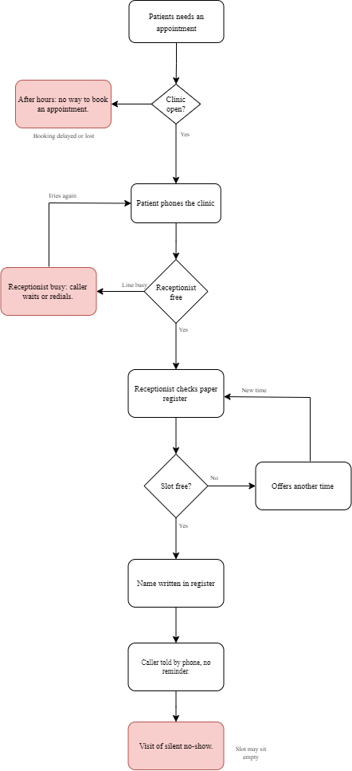
To-Be process: Online Booking with Reminders
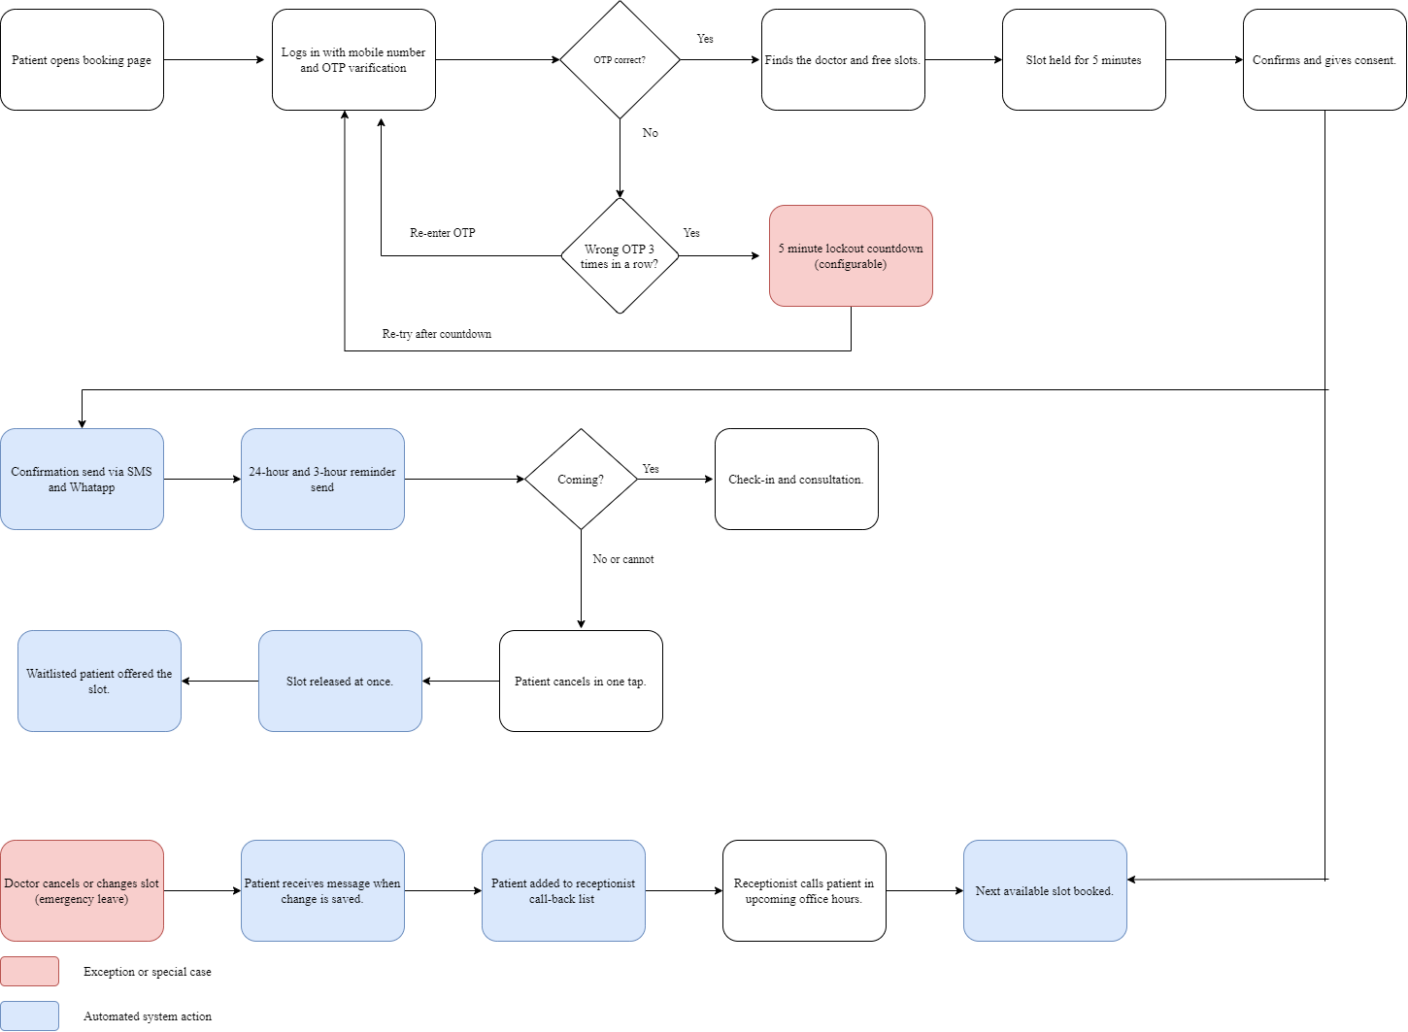

Functional Requirements
Functional requirements describe what the system shall do. Requirement priority is shown as a proposed MoSCoW rating. The Objective column links each requirement to the business objectives.
ID | Requirement | Priority | Objective
Registration and Access
FR-01 | Patients shall register and log in with their mobile number using a one-time password (OTP), which shall be delivered within 30 seconds. | Must | BO-2, BO-7
FR-02 | The system shall issue every patient a unique medical record number (MRN). | Must | BO-2
FR-03 | The system shall store the patient's name, date of birth, gender and mobile number. | Must | BO-2
FR-04 | The system shall provide role-based access for patient, receptionist, doctor and admin. | Must | BO-7
Doctor Search and Slot Selection
FR-05 | The system shall list doctors with specialty, qualification, languages and consultation hours. | Must | BO-2, BO-4
FR-06 | The system shall filter doctors by specialty, date and earliest availability. | Must | BO-4
FR-07 | The system shall display only slots that are currently free, within the advance booking window. | Must | BO-4
FR-08 | The system shall hold a selected slot for 5 minutes while the patient confirms, with a visible countdown. | Must | BO-4
FR-09 | The system shall prevent two active bookings in the same doctor slot. | Must | BO-7
Booking, Rescheduling and Cancellation
FR-10 | Patients shall be able to book appointments online. | Must | BO-2, BO-3
FR-11 | Patients shall be able to reschedule an appointment up to the configured cutoff (default 2 hours before start), choosing from free slots with the same doctor or another available doctor in the same department. | Must | BO-2
FR-12 | Patients shall be able to cancel an appointment and select a reason from a list. | Must | BO-2, BO-5
FR-13 | The system shall release the slot immediately on cancellation, and the release shall be reflected on the receptionist console. | Must | BO-5
FR-14 | The system shall show the patient the cancellation policy before the patient confirms a cancellation. | Should | BO-6
FR-15 | Patients shall be able to view upcoming and past appointments with status labels, and rebook a past doctor in one tap. | Should | BO-2, BO-6
Notifications and Reminders
FR-16 | The system shall send a confirmation by SMS and WhatsApp within 1 minute of booking, containing the doctor's name, date, time, clinic address and the patient's MRN. | Must | BO-1
FR-17 | The system shall send automatic reminders by SMS and WhatsApp: the first reminder 24 hours and the second 3 hours before the scheduled appointment time. | Must | BO-1
FR-18 | Each reminder shall include a link to confirm, reschedule or cancel the appointment in one tap. | Must | BO-1, BO-5
FR-19 | The system shall record the delivery status of every message. | Should | BO-1
FR-20 | The system shall notify patients through message when a doctor cancels or changes a slot, including due to emergency leave. | Must | BO-6
FR-21 | Patients shall be able to choose SMS or WhatsApp and a preferred language for messages. | Should | BO-6
Waitlist
FR-22 | Patients shall be able to join a waitlist for a doctor and date when no slot is free. | Should | BO-5
FR-23 | On cancellation, the system shall offer the freed slot to the first matching waitlisted patient and notify that patient. | Should | BO-5
FR-24 | The waitlisted patient shall have a 15-minute window to confirm the offer; if not confirmed, the offer shall pass to the next waitlisted patient. | Should | BO-5
Patient Feedback
FR-25 | Patients shall be able to submit feedback and rate their consultation experience. | Should | BO-6
Reception Console
FR-26 | Reception shall see a day and week calendar of all doctors in one view, with colour-coded appointment status. | Must | BO-3
FR-27 | Reception shall be able to book, reschedule and cancel appointments on behalf of a patient. | Must | BO-3
FR-28 | Reception shall be able to register a walk-in patient and assign the next free slot. | Must | BO-3
FR-29 | Reception shall be able to check in an arrived patient. | Must | BO-3
FR-30 | Reception shall be able to mark a patient as a no-show after the grace period. | Must | BO-1
FR-31 | The system shall allow reception to search patients by name, mobile number or MRN. | Must | BO-3
Doctor and Admin Console
FR-32 | Admin staff shall be able to manage doctor schedules and clinic hours in the system. | Must | BO-4
FR-33 | Admin or doctor shall be able to define weekly working hours, break times and slot length. | Must | BO-4
FR-34 | A doctor shall be able to block leave or a time range, with automatic notification to affected patients and creation of a call-back list for reception (FR-36). | Must | BO-6
FR-35 | A doctor shall see today's appointments with their status (booked, confirmed, checked-in, completed, no-show). | Must | BO-3
FR-36 | When a doctor cancels or changes slots due to emergency leave, the system shall add each affected patient to a call-back list for reception, shown at the start of the next office hours, so that reception can call the patient, explain the change and book the next available slot. | Must | BO-6

Non- Functional Requirements
ID | Requirement | Target | Priority
Performance and Capacity
NFR-01 | Doctor search results and slot lists shall load quickly for patients. | Under 3 seconds for 95% of requests | Must
NFR-02 | Patient search shall return matching results quickly. | Within 2 seconds | Must
NFR-03 | The system shall support the expected pilot load. | 500 concurrent users; 5,000 bookings per day | Should
Availability and Reliability
NFR-04 | Self-service booking features shall be available whenever patients need to book, including outside office hours. | 99.5% monthly uptime | Must
NFR-05 | The system shall never create two active bookings for one slot, even when requests arrive at the same moment. | Slot locking; zero double bookings in concurrency tests | Must
NFR-06 | Failed SMS or WhatsApp messages shall be retried and the outcome recorded. | Up to 3 retries, else clinic contact number appears. | Should
NFR-07 | Data shall be backed up and recoverable after a failure. | Daily backup; recovery point 24 hours; recovery time 4 hours | Must
Security
NFR-08 | Login shall be protected by OTP verification. After 3 consecutive wrong OTP entries, OTP entry shall be locked and a countdown shown. | 5-minute lockout (configurable); patient can retry OTP verification when the countdown ends. | Must
NFR-09 | Personal data shall be encrypted in transit and at rest. | Encrypted storage | Must
NFR-10 | Access shall be enforced by role on the server, and idle sessions shall expire. | Role checks on every request; 15-minute inactivity timeout | Must
Privacy and Compliance
NFR-11 | The system shall obtain explicit, informed consent before collecting personal data and store a record of it. | Consent screen at first login; consent version and time stored | Must
NFR-12 | The system shall collect only the data needed for booking and apply a configurable retention period. | Retention period set by admin | Should
NFR-13 | Patients shall be able to view, correct their personal data. | Self-service view and edit. | Must
NFR-14 | The system shall comply with India's Digital Personal Data Protection Act, 2023 and its Rules. | Legal review of notice, consent text and data handling before go-live | Must
Auditability
NFR-15 | The system shall log who viewed, created, changed or cancelled an appointment record. | Audit log retained 12 months; entries cannot be edited | Must
Usability, Accessibility and Localisation
NFR-16 | A first-time patient shall be able to complete a booking with minimal effort. | 5 steps or fewer from search to confirmation | Must
NFR-17 | The interface shall follow accessibility guidelines for contrast, keyboard use, labelled fields and resizable text. | WCAG 2.1 Level AA | Should
NFR-18 | The interface and message templates shall support more than one language. | English at launch, text structured for regional languages | Should
Compatibility and Maintainability
NFR-19 | The web application shall work on current browsers and on small mobile screens. | Latest Chrome, Safari, Edge, Firefox; screens from 360 px wide | Must
NFR-20 | Business rules shall be changeable without code changes. | Configurable: OTP lockout duration, cancellation cutoff, grace period, booking window, reminder timing, slot length | Should

Business Rules
Business rules are policies the system must enforce. Rules marked as configurable can be changed by the admin without code changes (NFR-20).
ID | Rule | Configurable
BRL-01 | A slot can hold at most one active appointment. | No
BRL-02 | Patients may reschedule or cancel until 2 hours before the start time. | Yes
BRL-03 | A patient not checked in within 15 minutes of the start time may be marked as a no-show. | Yes
BRL-04 | Waitlist offers expire after 15 minutes. | Yes
BRL-05 | The advance booking window is 30 days. | Yes
BRL-06 | Bookings for minors must be made under a guardian account. | No
BRL-07 | After 3 consecutive wrong OTP entries, OTP entry is locked for 5 minutes, then the patient may try again. | Yes

Appointment Status Cycle
An appointment moves through the statuses below. These statuses are used on the reception console, the doctor's view and in reports.
From | Event | To
Start | Patient or reception books | Booked
Booked | Reminder confirmed by patient | Confirmed
Booked/confirmed | Patient or receptionist cancels | Cancelled
Booked/confirmed | Rescheduled | Rescheduled (old slot released, new appointment Booked)
Booked/confirmed | Patient arrives. | Checked-in
Checked-in | Consultation ends | Completed
Booked or  Confirmed | Grace period passes with no  arrival | No-show

User Stories and Acceptance Criteria
Epic 1: Registration and Booking
US-01 Register with mobile number |  | Must (FR-01, FR-02, FR-03)
Story | As a new patient, I want to register using my mobile number and a one-time password, so that I can book without remembering a password.
Acceptance criteria | - Given I enter a valid mobile number, when I request an OTP, then I receive it within 30 seconds.  - Given I enter the correct OTP, when I submit it, then my account is created and a unique MRN (Medical Record Number) is generated for me.  - Given I complete my details, when I save, then my name, date of birth, gender and mobile number are stored.  - Given I enter a wrong OTP 3 times in a row, when I try again, then a 5-minute countdown is shown, and I can retry OTP verification once it ends (configurable, NFR-08)

US-02 Search doctors |  | Must (FR-05, FR-06)
Story | As a patient, I want to search doctors by specialty and date, so that I can find the earliest suitable slot.
Acceptance criteria | - Given I select a specialty, when results load, then I see each doctor's specialty, qualification, languages and consultation hours.  - Given I choose a date, when I apply the filter, then only doctors with free slots on that date appear.  - Given I filter by earliest availability, when results load, then doctors with the earliest free slot appear first.  - Given no doctor has a free slot, when results load, then I see a message and an option to join the waitlist.

US-03 Select and confirm a slot |  | Must (FR-07, FR-08, FR-09, FR-10)
Story | As a patient, I want to pick a free slot and confirm it, so that my visit is secured.
Acceptance criteria | - Given a doctor's calendar, when I open it, then only free slots can be selected.  - Given I select a slot, when I proceed, then the slot is held for 5 minutes with a visible countdown.  - Given two patients select the same slot, when both confirm, then only the first confirmation succeeds and the other patient sees alternatives.  - Given the hold has expired, when 5 minutes pass, then the slot returns to the pool and I am asked to reselect.

US-04 Immediate confirmation |  | Must (FR-16)
Story | As a patient, I want an immediate confirmation, so that I know my booking is real.
Acceptance criteria | - Given I confirm a booking, when it is saved, then I see a confirmation with doctor, date, time, clinic address and my MRN.  - Given the booking is saved, when 1 minute passes, then I receive the same details by SMS and WhatsApp.

US-05 Reschedule an appointment |  | Must (FR-11, BRL-02)
Story | As a patient, I want to move my appointment, so that I do not need to cancel and rebook.
Acceptance criteria | - Given an appointment more than 2 hours away, when I choose Reschedule, then I see free slots for the same doctor or another available doctor in the same department.  - Given I select a new slot, when I confirm and it is saved, then the old slot is released and I receive a new confirmation.  - Given the appointment is within 2 hours, when I open it, then Reschedule is disabled and the page shows the clinic phone number or redirects to the booking page.

US-06 Cancel an appointment |  | Must (FR-12, FR-13, FR-14)
Story | As a patient, I want to cancel quickly, so that someone else can use the slot.
Acceptance criteria | - Given an appointment before the cutoff, when I tap Cancel, then I must pick a reason and confirm.  - Given I confirm, when it saves, then the slot becomes available immediately and I receive a cancellation message.  - Given the cancellation policy, when I view the screen, then the policy text is shown before I confirm.

US-07 View my appointments |  | Should (FR-15)
Story | As a patient, I want to see upcoming and past appointments, so that I can track my visits.
Acceptance criteria | - Given I open My Appointments, when the page loads, then upcoming appointments appear first with status labels.  - Given a past appointment, when I open it, then I can rebook the same doctor in one tap.

Epic 2: Reminders and Confirmation
US-08 Be told when my appointment changes |  | Must (FR-20, FR-36)
Story | As a patient, I want to be told when anything about my appointment changes, so that I am never surprised.
Acceptance criteria | - Given I reschedule, when it saves, then I receive the new time by message.  - Given my doctor cancels or changes my slot due to emergency leave, when the change is saved, then I receive a message about it, and the clinic office calls me during the upcoming office hours to explain and book the next available slot.

US-09 Reminder the day before |  | Must (FR-17, FR-18)
Story | As a patient, I want a reminder the day before, so that I do not forget.
Acceptance criteria | - Given an appointment is 24 hours away, when that time arrives, then I receive a reminder by SMS and WhatsApp with a one-tap link to confirm, reschedule or cancel.  - Given the reminder, when I tap Confirm, then my status becomes Confirmed.  - Given the reminder, when I tap Cancel, then the cancellation flow opens with the reason list.  - Given I have already cancelled, when the reminder time arrives, then no reminder is sent.

US-10 Short reminder before the visit |  | Must (FR-17, FR-18)
Story | As a patient, I want a short reminder just before the visit, so that I leave on time.
Acceptance criteria | - Given an unconfirmed or confirmed appointment, when 3 hours remain, then I receive a short reminder with a map link.

US-11 Choose message channel and language |  | Should (FR-19, FR-21)
Story | As a patient, I want to choose SMS or WhatsApp and a language, so that messages suit me.
Acceptance criteria | - Given my message settings, when I choose a channel and language, then future messages follow my choice.  - Given any message is sent, when it is delivered or fails, then the delivery status is recorded.

Epic 3: Waitlist
US-12 Join a waitlist |  | Should (FR-22)
Story | As a patient, I want to join a waitlist when no slot suits me, so that I get one if it opens.
Acceptance criteria | - Given no slot is free for my chosen doctor and date, when I choose Join waitlist, then I am added to the waitlist for that doctor and date.  - Given I am on a waitlist, when I leave it, then I am removed and no further offers are sent.

US-13 Receive and accept a slot offer |  | Should (FR-23, FR-24)
Story | As a waitlisted patient, I want a quick offer when a slot frees up, so that I can take it.
Acceptance criteria | - Given a matching slot is cancelled, when the system runs, then the first matching waitlisted patient is notified of the offer.  - Given I accept within 15 minutes, when I tap Accept, then the booking is confirmed.  - Given I do not respond within 15 minutes, when the timer ends, then the offer passes to the next patient.  - Given the slot is taken by someone else first, when I tap Accept, then I see an apology and nearby alternatives.

Epic 4: Doctor and Admin Schedule
US-14 Set doctor hours and slot length |  | Must (FR-32, FR-33)
Story | As an admin, I want to set each doctor's weekly hours, breaks and slot length, so that patients see correct availability for the next 30 days.
Acceptance criteria | - Given I set hours, breaks and slot length for a doctor, when I save, then slots are generated for the next 30 days and none overlaps a break.  - Given existing bookings, when I change hours, then affected bookings are listed for review before saving.

Epic 5: Reception Console
US-15 View one calendar of all doctors |  | Must (FR-26, FR-31)
Story | As a receptionist, I want one calendar of all doctors, so that I can answer any request in seconds.
Acceptance criteria | - Given I log in, when the console opens, then I see today's appointments for all doctors with colour-coded status.  - Given I type a name, mobile number or MRN, when I search, then matching patients appear within 2 seconds.

US-16 Book, move or cancel for a caller |  | Must (FR-27)
Story | As a receptionist, I want to book, move or cancel for a caller, so that phone patients are served in the same system.
Acceptance criteria | - Given a caller, when I search by mobile number, then an existing profile loads or I can create one quickly.  - Given I book for a caller, when I save, then a confirmation message is sent and the channel is recorded as Phone.

US-17 Register a walk-in |  | Must (FR-28)
Story | As a receptionist, I want to add walk-in patients to the next free slot, so that nobody is turned away unrecorded.
Acceptance criteria | - Given a walk-in patient, when I choose a doctor, then the next free slot is suggested.  - Given no slot is free today, when I search, then the system offers the next available day.

US-18 Check in and record no-shows |  | Must (FR-29, FR-30)
Story | As a receptionist, I want to check patients in and record no-shows, so that data stays accurate.
Acceptance criteria | - Given a patient arrives, when I tap Check in, then the doctor's list shows them as waiting.  - Given 15 minutes have passed after the start time with no check-in, when I open the appointment, then Mark no-show is enabled.

US-19 Call back affected patients |  | Must (FR-36, FR-27)
Story | As a receptionist, I want a call-back list of patients affected by a doctor’s emergency leave, so that I can call them during office hours and rebook.
Acceptance criteria | - Given slots were cancelled due to emergency leave, when office hours start, then I see the affected patients with their original appointment details.  - Given I call a patient, agree on a new time, then I book the next available slot and mark the call as done.

Epic 6: Doctor View
US-20 See today's patients |  | Must (FR-35)
Story | As a doctor, I want to see today's patients and statuses, so that I can plan my day.
Acceptance criteria | - Given I log in, when the page loads, then I see today's appointments in time order with status (booked, confirmed, checked-in, completed, no-show).  - Given a patient is checked in, when the status changes, then my list shows the updated status.

US-21 Block dates or hours |  | Must (FR-34)
Story | As a doctor, I want to block dates or hours, so that no one books me while I am away.
Acceptance criteria | - Given I select a date range, when I save, then those slots disappear from patient search.  - Given existing bookings fall in the blocked range, when I save, then I see the affected bookings, the patients are notified, and they are added to the reception call-back list.

Epic 7: Patient Feedback
US-22 Rate my consultation |  | Should (FR-25)
Story | As a patient, I want to rate my consultation and leave feedback, so that the clinic can improve its service.
Acceptance criteria | - Given my appointment is completed, when I open the feedback form, then I can give a rating from 1 to 5 and an optional comment.  - Given I submit feedback, when it is saved, then the rating is stored against that appointment.

Exception Flows
ID | Case | Handling | Related
EX-01 | OTP not received | Patient can request a new OTP after 30 seconds. | FR-01
EX-02 | Two patients pick the same slot | The first confirmation wins; the other patient is shown alternatives. | FR-09, NFR-05
EX-03 | Hold expires after 5 minutes | The slot returns to the pool and the patient is asked to reselect. | FR-08
EX-04 | Doctor falls sick | Affected slots are cancelled; patients receive a message when the change is saved, and reception calls them during the upcoming office hours to explain and book the next available slot. | FR-20, FR-34, FR-36
EX-05 | Patient arrives late | Reception decides within the grace period; after 15 minutes the slot may be released. | FR-30, BRL-03
EX-06 | Patient has no smartphone | Reception books by phone in the same console. | FR-27
EX-07 | Message delivery fails | The system retries up to 3 times and records the status; reception can follow up by phone. | FR-19, NFR-06
EX-08 | Wrong OTP entered 3 times | A countdown of 5 minutes (configurable) is shown; the patient can retry when it ends | FR-01, NFR-08, BRL-07.

Requirements Traceability Matrix
The matrix shows which requirements, stories and exception flows support each business objective.
Objective | Functional | Non-functional | User stories | Exceptions
BO-1 No-shows | FR-16 to FR-19, FR-30 | NFR-06 | US-04, US-08 to US-10 | EX-07
BO-2 Self-service | FR-01 to FR-03, FR-05, FR-10 to FR-12, FR-15 | NFR-04, NFR-16 | US-01 to US-07 | EX-01
BO-3 Reception time | FR-10, FR-26 to FR-29, FR-31, FR-35 | NFR-02 | US-15 to US-19 | EX-06
BO-4 Time to book | FR-05 to FR-08, FR-32, FR-33 | NFR-01, NFR-16 | US-02, US-03, US-14 | EX-03
BO-5 Idle capacity | FR-12, FR-13, FR-18, FR-22 to FR-24 | NFR-05 | US-06, US-12, US-13 | EX-02
BO-6 Experience | FR-14, FR-15, FR-20, FR-21, FR-25, FR-34, FR-36 | NFR-17, NFR-18 | US-07, US-08, US-11, US-19, US-21 | EX-04
BO-7 Security | FR-01, FR-04, FR-09 | NFR-08 to NFR-15 | US-01, US-14 | EX-08

